**Object Oriented Analysis and Design**

**Automated Bill Payment System**

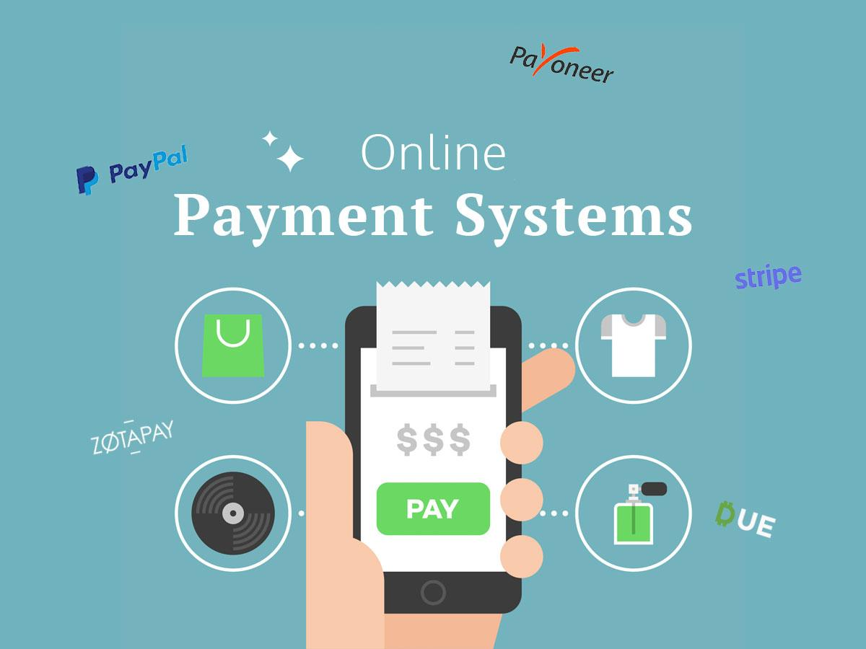

**Submitted to**:

Ma’am Amina mirza

**Group Members:**

Bsef19m013 - Osama Sultan

Bsef19m032 - Ameena Abdullah

Bsef19m029 - Iqra Hanif

**Automated Bill payments Application**

**Table of Contents**

1. Introduction  
   1.1- Vision and Scope
2. Supplementary specifications
3. Major Requirements (FURPS+)  
   3.1- Functionalities  
    3.1.1- Employee End  
    3.1.2- Admin End  
   3.2- Usability  
   3.3- Reliability  
   3.4- Performance  
   3.5- Supportability
4. Feature List
5. Domain Rules
6. Risk List
7. Feasibility  
   7.1- Timeline  
   7.2- Technical  
   7.3- Financial
8. Use Cases  
   8.1- Actors  
   8.2- Goals  
   8.3- Use Cases
9. Activity Diagram(Swim lanes)
10. Business level use case diagram
11. Analysis level use case diagram
12. Package Diagram
13. State Chart diagram
14. Glossary
15. **Introduction**

A Company owner wants his employees to be tension-free from all aspects so that they can give their best at work. So, he decides to design a system where the salaries of his employees will be transferred every month and that system will be integrated with banks so that all types of bills that employees pay like electricity/gas or internet or any other services that can be paid online will be deducted automatically from their salaries.

**Vision and Scope:**

The company needs an application that can automatically deduct bills of employees. The scope of this project is to implement the functionalities of an automated bill payment system for a company. It focuses on the stakeholders' needs and employee will (whether he/she wants to pay the bill or not). The basic purpose of this software is to provide ease to the employees in terms of paying bills so that they don’t have to worry about the deadlines of bills so that it can improve the working capability of employees. Also, they’ll have a net amount of income that they can spend on their daily expenditures.

1. **Supplementary Specifications**

* Generate Unique Id and password for each employee
* Integrated Attendance system.
* Checkboxes for employees to select the type of bills to pay or not.
* Salary Reports and salary slip

1. **Major Requirements**

**Functionalities:**

* System shall ask user to login as admin or employee

**Employee End:**

* System shall ask employees username and password and verify.
* System shall provide a proper interface to employees for selection of what to do. (Employee functions are discussed in laterer points)
* System shall show personal and billing information of the employee.
* System shall ask employees to select/unselect bill types he/she wants to pay or not.
* System shall allow employees to view attendance records. (Integrated an already implemented software)
* System shall provide a proper interface to request any change in information.

**Admin End:**

* System shall ask admin username and password and verify.
* System shall provide proper interfaces to perform CRUD operations.
* System shall generate username and password for employees whenever a new employee is added.
* System shall check the types of bills the employee wants to pay.
* System will fetch data from the billing site on a specific day and pay the bill for respective users.
* System shall send automated messages to the employee after bill payment.
* System shall check bill payment status from the fetched data and decide whether to pay the bill or not.

**Usability:**

* Company system managers will have an interface to add/delete/update employee information and manage other application functionalities.
* Employees will be able to view details and billing status at his/her end with a proper interface.

.

**Reliability:**

* Application shall be available all the time for company and employees so employees can view status/details any time, similarly company managers can perform required functionalities any time.

**Performance:**

* The number of employees in the company ranges from 2000-2500, so the system must be powerful enough to handle the situation if all employee’s login at the same time.
* Depending on the strength of the Internet connection, the system will take loading times accordingly.
* Productivity of the system will also depend on the user hardware components.

**Supportability:**

* Software must be supported on android/iPhone/windows and mac OS.

1. **Feature List:**

* Login
* Login as a Manager
* Login as a admin
* Bill payment Service
* Check Bill Status
* Pay bills (Electricity, water Sanitation, Sui gas)
* Bills Verification
* Bills Record
* Attendance system(integrated)
* Edit/Update Attendance
* View Attendance
* Delete Attendance
* Manage Employee
* Employee Personal Details (Name, ID, Password, Address etc.)
* Find/Search Employee
* Edit/Update Employee
* Delete Employee
* View Employee List
* Salary Report
* Generate Salary Slip
* Calculate Salary
* Send Salary Slip
* Salary Record
* Update Profile
* Edit Personal Information

1. **Domain Rules**

* **Fine on Late payment of bills**

If the bills are not paid on the due date, there will be a certain amount that will be deducted/needed to pay as fine. The late payment of bills is explicitly outlined.

* **Tax amount on bills**

A tax amount is the percentage at which an individual or corporation is taxed. There will be a certain amount that is charged as a tax by govt or other organizations from the salary of each individual employee. The system will be responsible to pay tax of each employee that will be deducted from their salaries.

* **Audit Report of company/Employee**

An audit report is a written opinion of an auditor regarding an entity's financial statements. The system will also be able to prepare the audit report of the company/each employee.

1. **Risk List**

The factors that need to be considered during the audit of a project are risks. To keep the side safe risks are handled on time.

* **Cyberattacks on Employee information.**

There is a risk of leakage of employee’s personal information that can cause cyberattack.

* **System Crashes:**

If system crashes and bills are not paid, the company will face heavy loss in terms of fines.

1. **Feasibility**

**Timeline:**

This project can be completed within the time because it has less number of major functionalities to implement.

**Technical:**

All hardware and software requirements are generic and in common use, so this project is technically feasible.

**Financial:**

The company is well reputed and a profit-making company, so this project is financially feasible.

1. **Use Cases**

**Actors:**

* **Primary Actors**
* Employee
* System Manager
* **Secondary**
* Bank
* Accounts Dept
* Audit Department
* **Offstage**
* Service Providing Company(To whom bill is paid)

**Goals:**

|  |  |
| --- | --- |
| **Actors** | **Goals** |
| Employee | Bill payments as a service user |
| System Manager | Add employees to the list and manage all major functionalities to keep all records updated. |
| Bank | Receive all the bills and transfer to respected organization |
| Accounts Dept | To transfer Salary and keep record of total bill amounts. |
| Audit Dept | Keep record of income and expenditures |
| Service Providing Company | Provide service to employees/Users for which they are paying bills. |

**Use Cases:**

* Login
* View Employee Information
* Salary Details
* Add New Employee
* Delete Employee
* Send update request
* Update Employee information
* Bills Payment
* Attendance System
* Bills Records
* Maintain Employee List
* Manage Employee Permission

**Casual description of Use Cases:**

**Use Case 1: Bill Payment**

**Main Success scenario:**Data is fetched from the site and the bill is paid. Status of bill payment will be updated and the amount of bill will be deducted from employee salary. Employee will get the amount left after deduction as his/her salary.

**Alternative scenarios:**

* If data is fetched and the bill is not yet uploaded by a service providing company, it will not change the payment status and check information again after 12 hours.
* If the bill amount is in some cases more than the salary of the employee it’ll send a query to the employee and admin about the case and bill payment status will remain unpaid.

**Use Case 2: Manage Employee Permissions for bill types**

Whenever any facility is given to employee/User permissions are necessary for better services and sometimes for user will.

**Main Success scenario:**Employee will get an interface where different services will be given and employee has to check which services he/she is using and provide consumer/bill id.

**Alternative scenarios:**

* If none is selected then salary will be transferred directly to account without any wait for billing dates.
* If bill information provided by an employee after selecting a service is wrong an error message will be sent to employee and admin immediately and employee will send update request to admin.

1. **Activity Diagram (Swim Lanes)**

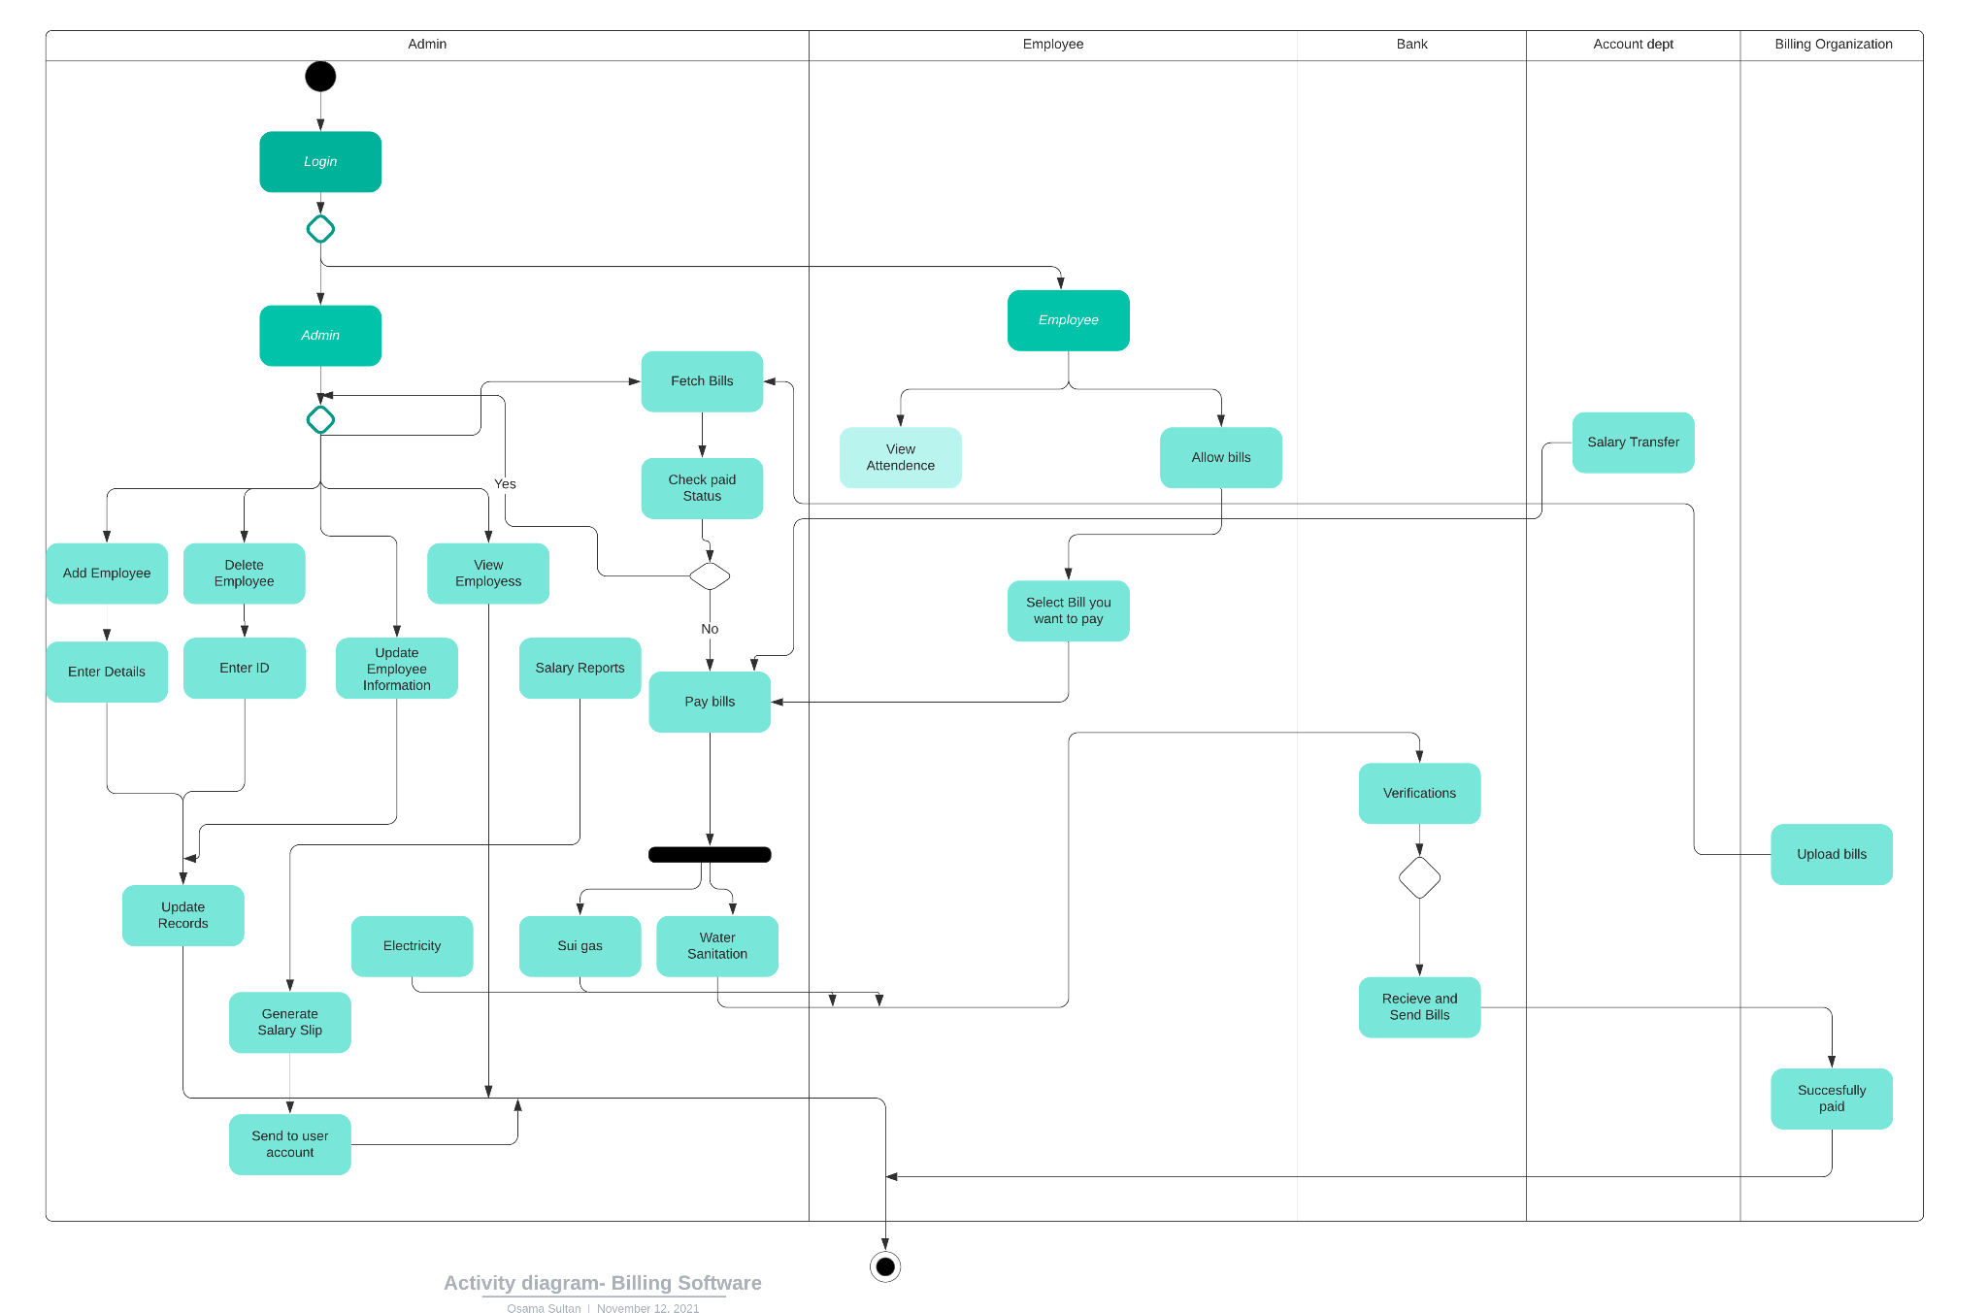

1. **Business Level/Use Case Diagram**

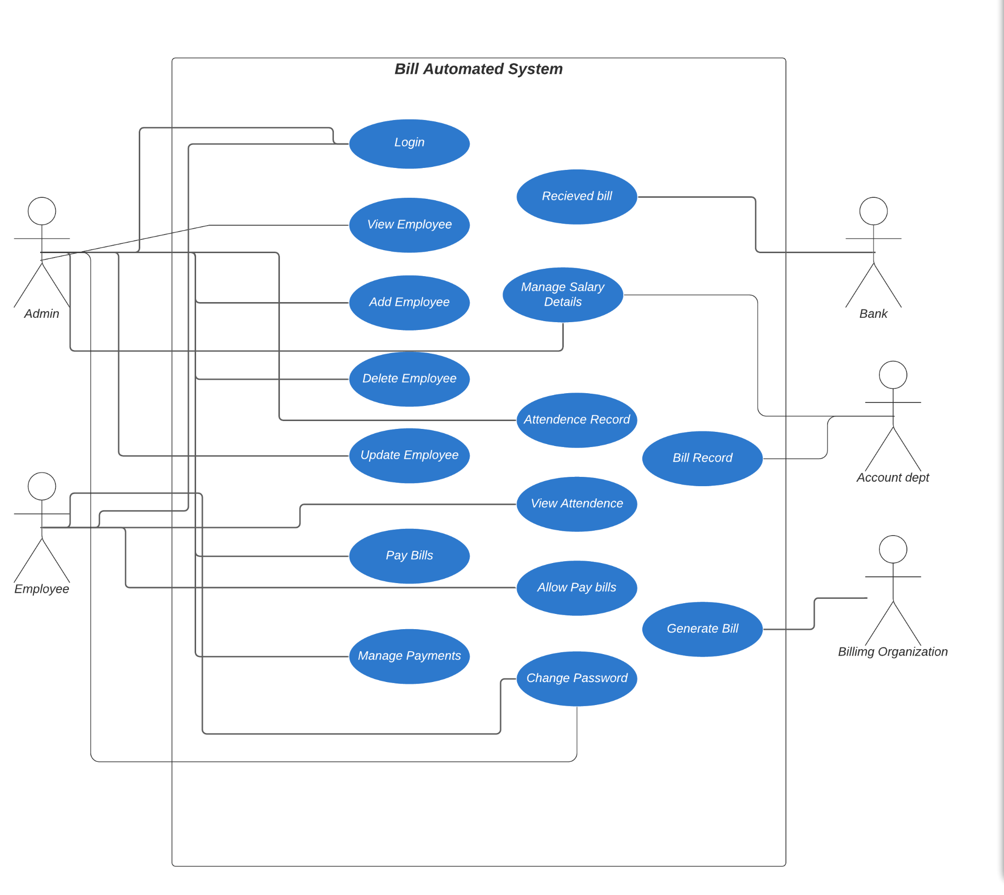

1. **Analysis Level Use Case Diagram**

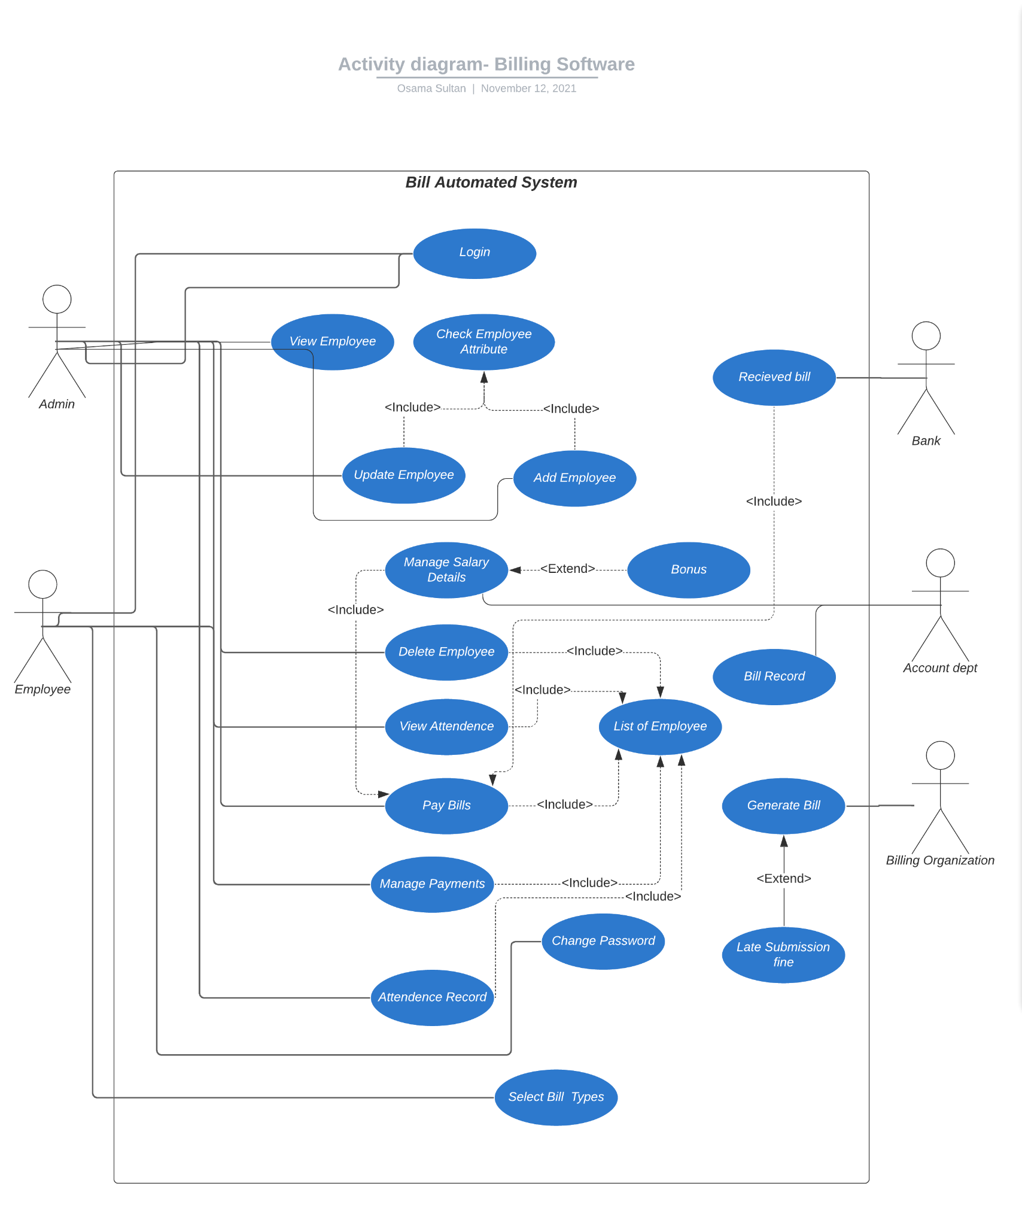

1. **Package Diagram**

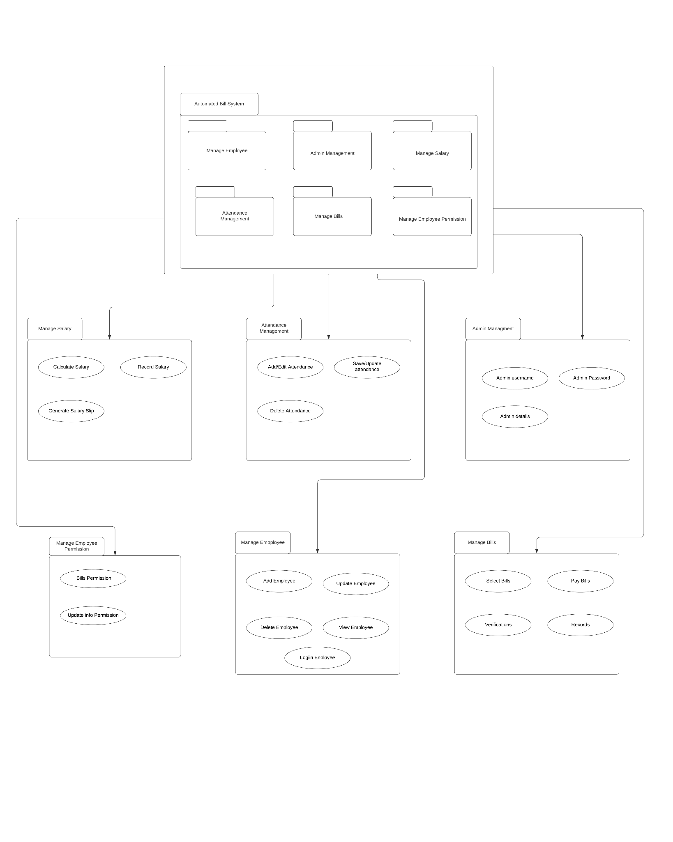

1. **State Chart Diagram**

**Employee:**

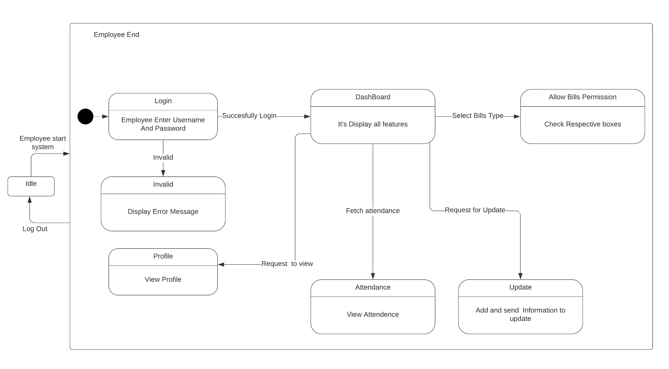

**Admin:**

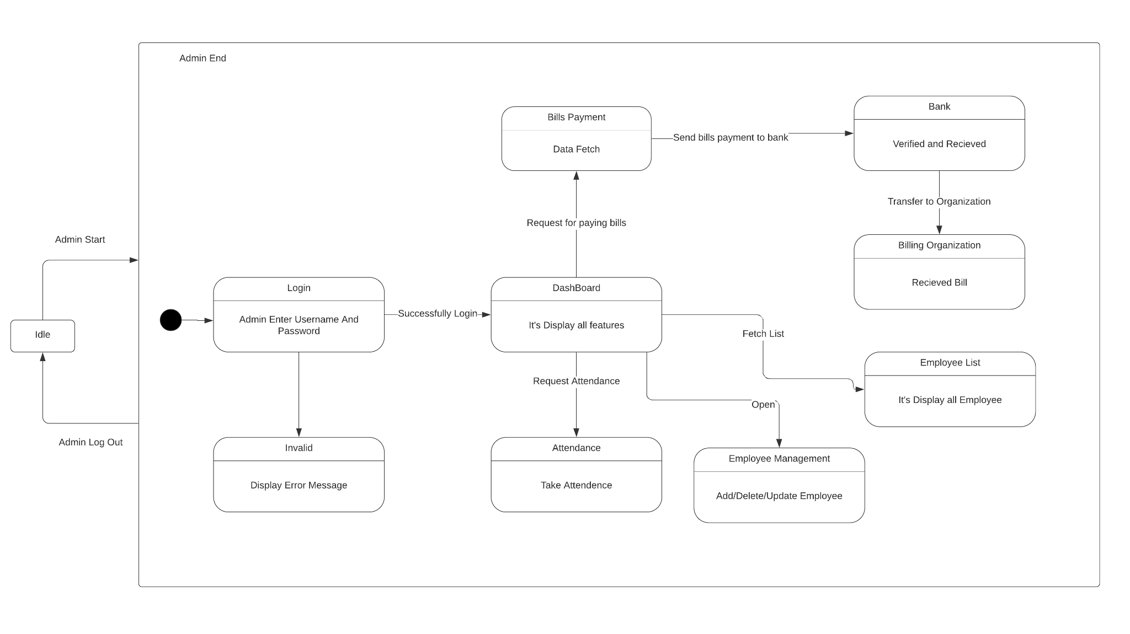

1. **Glossary**

|  |  |
| --- | --- |
| **Word** | **Description** |
| Organization | Company which is providing services and employee has to give bill |
| Audit Report | Citizen report of income and expenditures for which tax is calculated |
| Integrated system | Already implemented system which is used as a supplementary requirement for project |